**Software Project Management Plan**

**Synchronous Spotify Playback Web Application**

**Jeremy Hunat - COSC 412**

**10/18/2020**

**Table of Contents**

1. **Introduction**
   1. Project Overview
   2. Project Deliverables
   3. Evolution of the SPMP
   4. Reference Materials
2. **Project Organization**
   1. Process Model
3. **Managerial Process**
   1. Management Objectives and Priorities
   2. Assumptions, Dependencies and Constraints
   3. Risk Management
   4. Monitoring and Controlling Mechanism
4. **Technical Process**
   1. Methods, Tools and Techniques
   2. Software Documentation
   3. Project Support Functions
5. **Description of Work Packages**
   1. Work Breakdown Structure
   2. Gantt Chart
   3. **Project Overview**

This project is a web-based app that allows users to connect their Spotify account to play music synchronously amongst other friends who have a valid code from the host to host a listening session. No sign-up is required for the web-app, only a Spotify account (either Free or Premium). Upon visiting the website, the user is prompted to either join an existing room or be a host of a listening session. A host would need to create a private room and share the private key to friends. Friends would just need to follow the link and connect their account to join the session. Other features will be added in the future, such as song request/playlist request, having the ability to browse what your friends are currently listening to and create a session from a simple request.

* 1. **Project Deliverables**

1. Project Planning
2. Requirements Specification/Use Cases
3. Tool Selection
4. Analysis
5. Testing
6. Final Deliverable
   1. **Evolution of the SPMP**

This initial draft of the Software Project Management Plan will be updated as the project progresses. After each subsequent feature added extensive testing will take place before moving onto the next target feature. Some features might be added or removed after the publication of this draft, depending on the complexity of said feature.

* 1. **Reference Materials**

This Software Project Management Plan references the following resources.

* [Spotify Web API](https://developer.spotify.com/documentation/web-api/)
* [Mutation Observer](https://developer.mozilla.org/en-US/docs/Web/API/MutationObserver)
* [Firebase Realtime Database](https://firebase.google.com/docs/database)
* [Plug.dj](https://plug.dj/dashboard)
  1. **Process Model**

The process model used for this project will be a spiral model which allows us to iteratively work on each feature piece-by-by but also leaves room for backtracking. On each feature we identify and resolve risk and do extensive test before moving onto the next one.

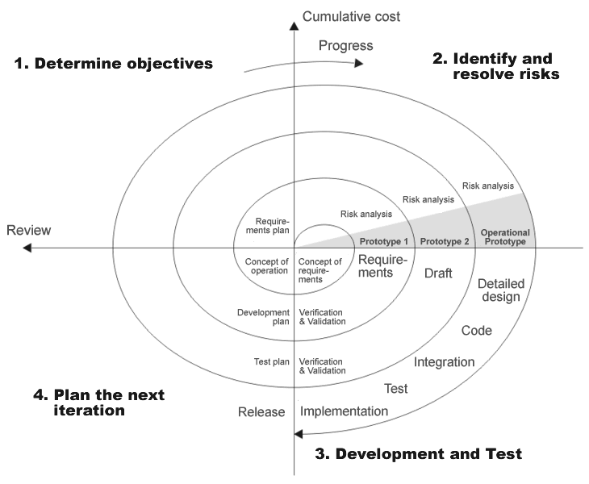

* 1. **Management Objectives and Priorities**

The management objective is to deliver a product that is easy to use for all users, with the wide range of people that has a Spotify account it would be beneficial to have an option of create a listening session with your friends to listen to music to. We strive to make the website widely accessible to any platform that has access to a Web Browser, as well on mobile devices. With the added benefit of it being a PWA in the future, users wouldn’t have to get the app through the App Store, and it would still function on mobile as it would a normal app. We are constantly making preemptive measures to ensure that the end product is of high quality.

* 1. **Assumptions, dependencies, and constraint**
* Project Deadline by the 13th of November.
* Lack of Budget for hosting.
* Limited number of concurrent listeners using Firebase.
  1. **Risk Management**
* Financial risk
* Technical risk
* Process risk
* Handover risk
  1. **Monitoring and Controlling Mechanisms**
* Version Control
* Weekly deliberation
* Closed-beta feedback
  1. **Methods, Tools, and Techniques**

The project will be built using the following tools and languages: Microsoft Visual Studio Code, HTML, CSS, JavaScript, React, Node.js and will be hosted on AWS servers with Firebase database. There will be beta-testers when the building the app and their feedback will be considered when making adjustments to the project.

* 1. **Software Documentation**

Documentation such as project charter, Business Requirement Document, Functional Specification document, Cost Benefit Analysis, Technical Specification document, detail design document, Test Plan, Implementation Plan, and Benefit Realization document.

* 1. **Project Support Functions**

The project will be closely monitored after the publication of the web application to ensure the integrity of the project. Tweaks and modifications can be added to the project whenever feedback/criticism is made on the project.

* 1. **Work Breakdown Structure**

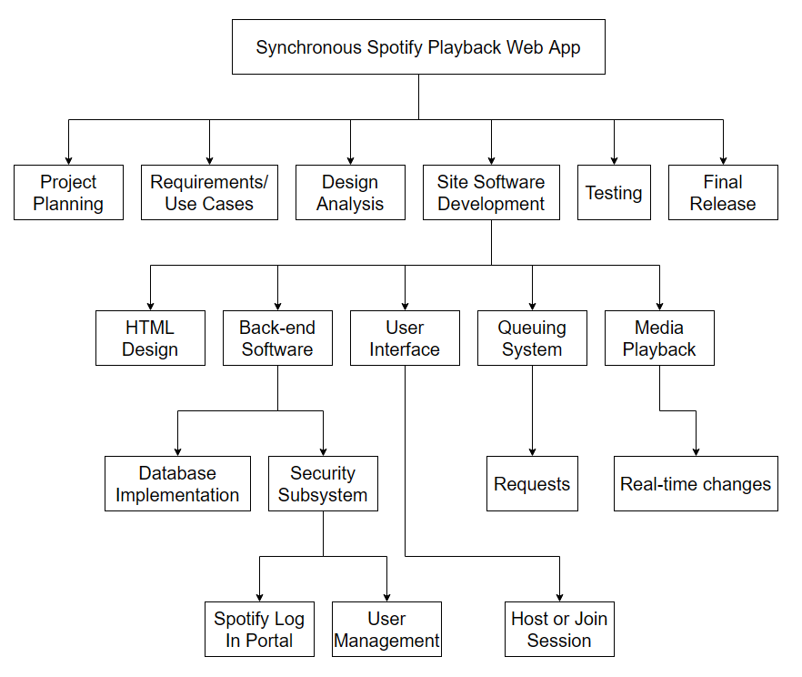

* 1. **Gantt Chart**

